- The slowdown in UK CPI inflation in May was broadly as expected. We think headline inflation will stabilise around the 2% mark in the next few months as downward pressure from the food and services categories is offset by base effects in the energy component.
- But the recent uptick in wholesale gas prices means we now think the energy category will weigh less heavily on headline inflation around the turn of the year. So though we still expect CPI inflation to average 2.5% in 2024, we have raised our 2025 forecast to 2.5%, from 2.3% last month.
In line with our forecast, CPI inflation fell to 2% in May from 2.3% in April. May's softer headline rate reflected lower contributions from the food and core categories, due to the combination of base effects and companies passing on their lower energy costs to consumers. Services inflation slowed to 5.7% from 5.9% in April. Though this was a slightly smaller decline than we had expected, this partly reflected an unusual rise in air fares – a notoriously erratic category – which should unwind in next month's release. RPI and RPIX inflation fell to 3% and 1.9% respectively in May, from 3.3% and 2.3% in April.
The recent increase in gas futures prices, together with a slightly higher assumption for wholesale gas prices moving forward, means we now think that the energy category will weigh less heavily on headline inflation in late-2024 and in 2025. Therefore, though we still expect CPI inflation to average 2.5% in 2024, we have now raised our 2025 projection to 2.5% too, 0.2ppts higher than last month's forecast.
Price pressures in the food and services sectors should continue to fade as further base effects come into play and firms gradually reflect their lower energy costs in consumer prices. This is likely to be offset by base effects in the energy category caused by last year's sharp price drops. This should keep headline inflation around the 2% mark in the next few months. But we expect the shrinking drag from the energy category to start pushing inflation up more noticeably towards the end of this year.
Chart 1: A higher gas price assumption has raised our 2025 inflation forecast to 2.5%
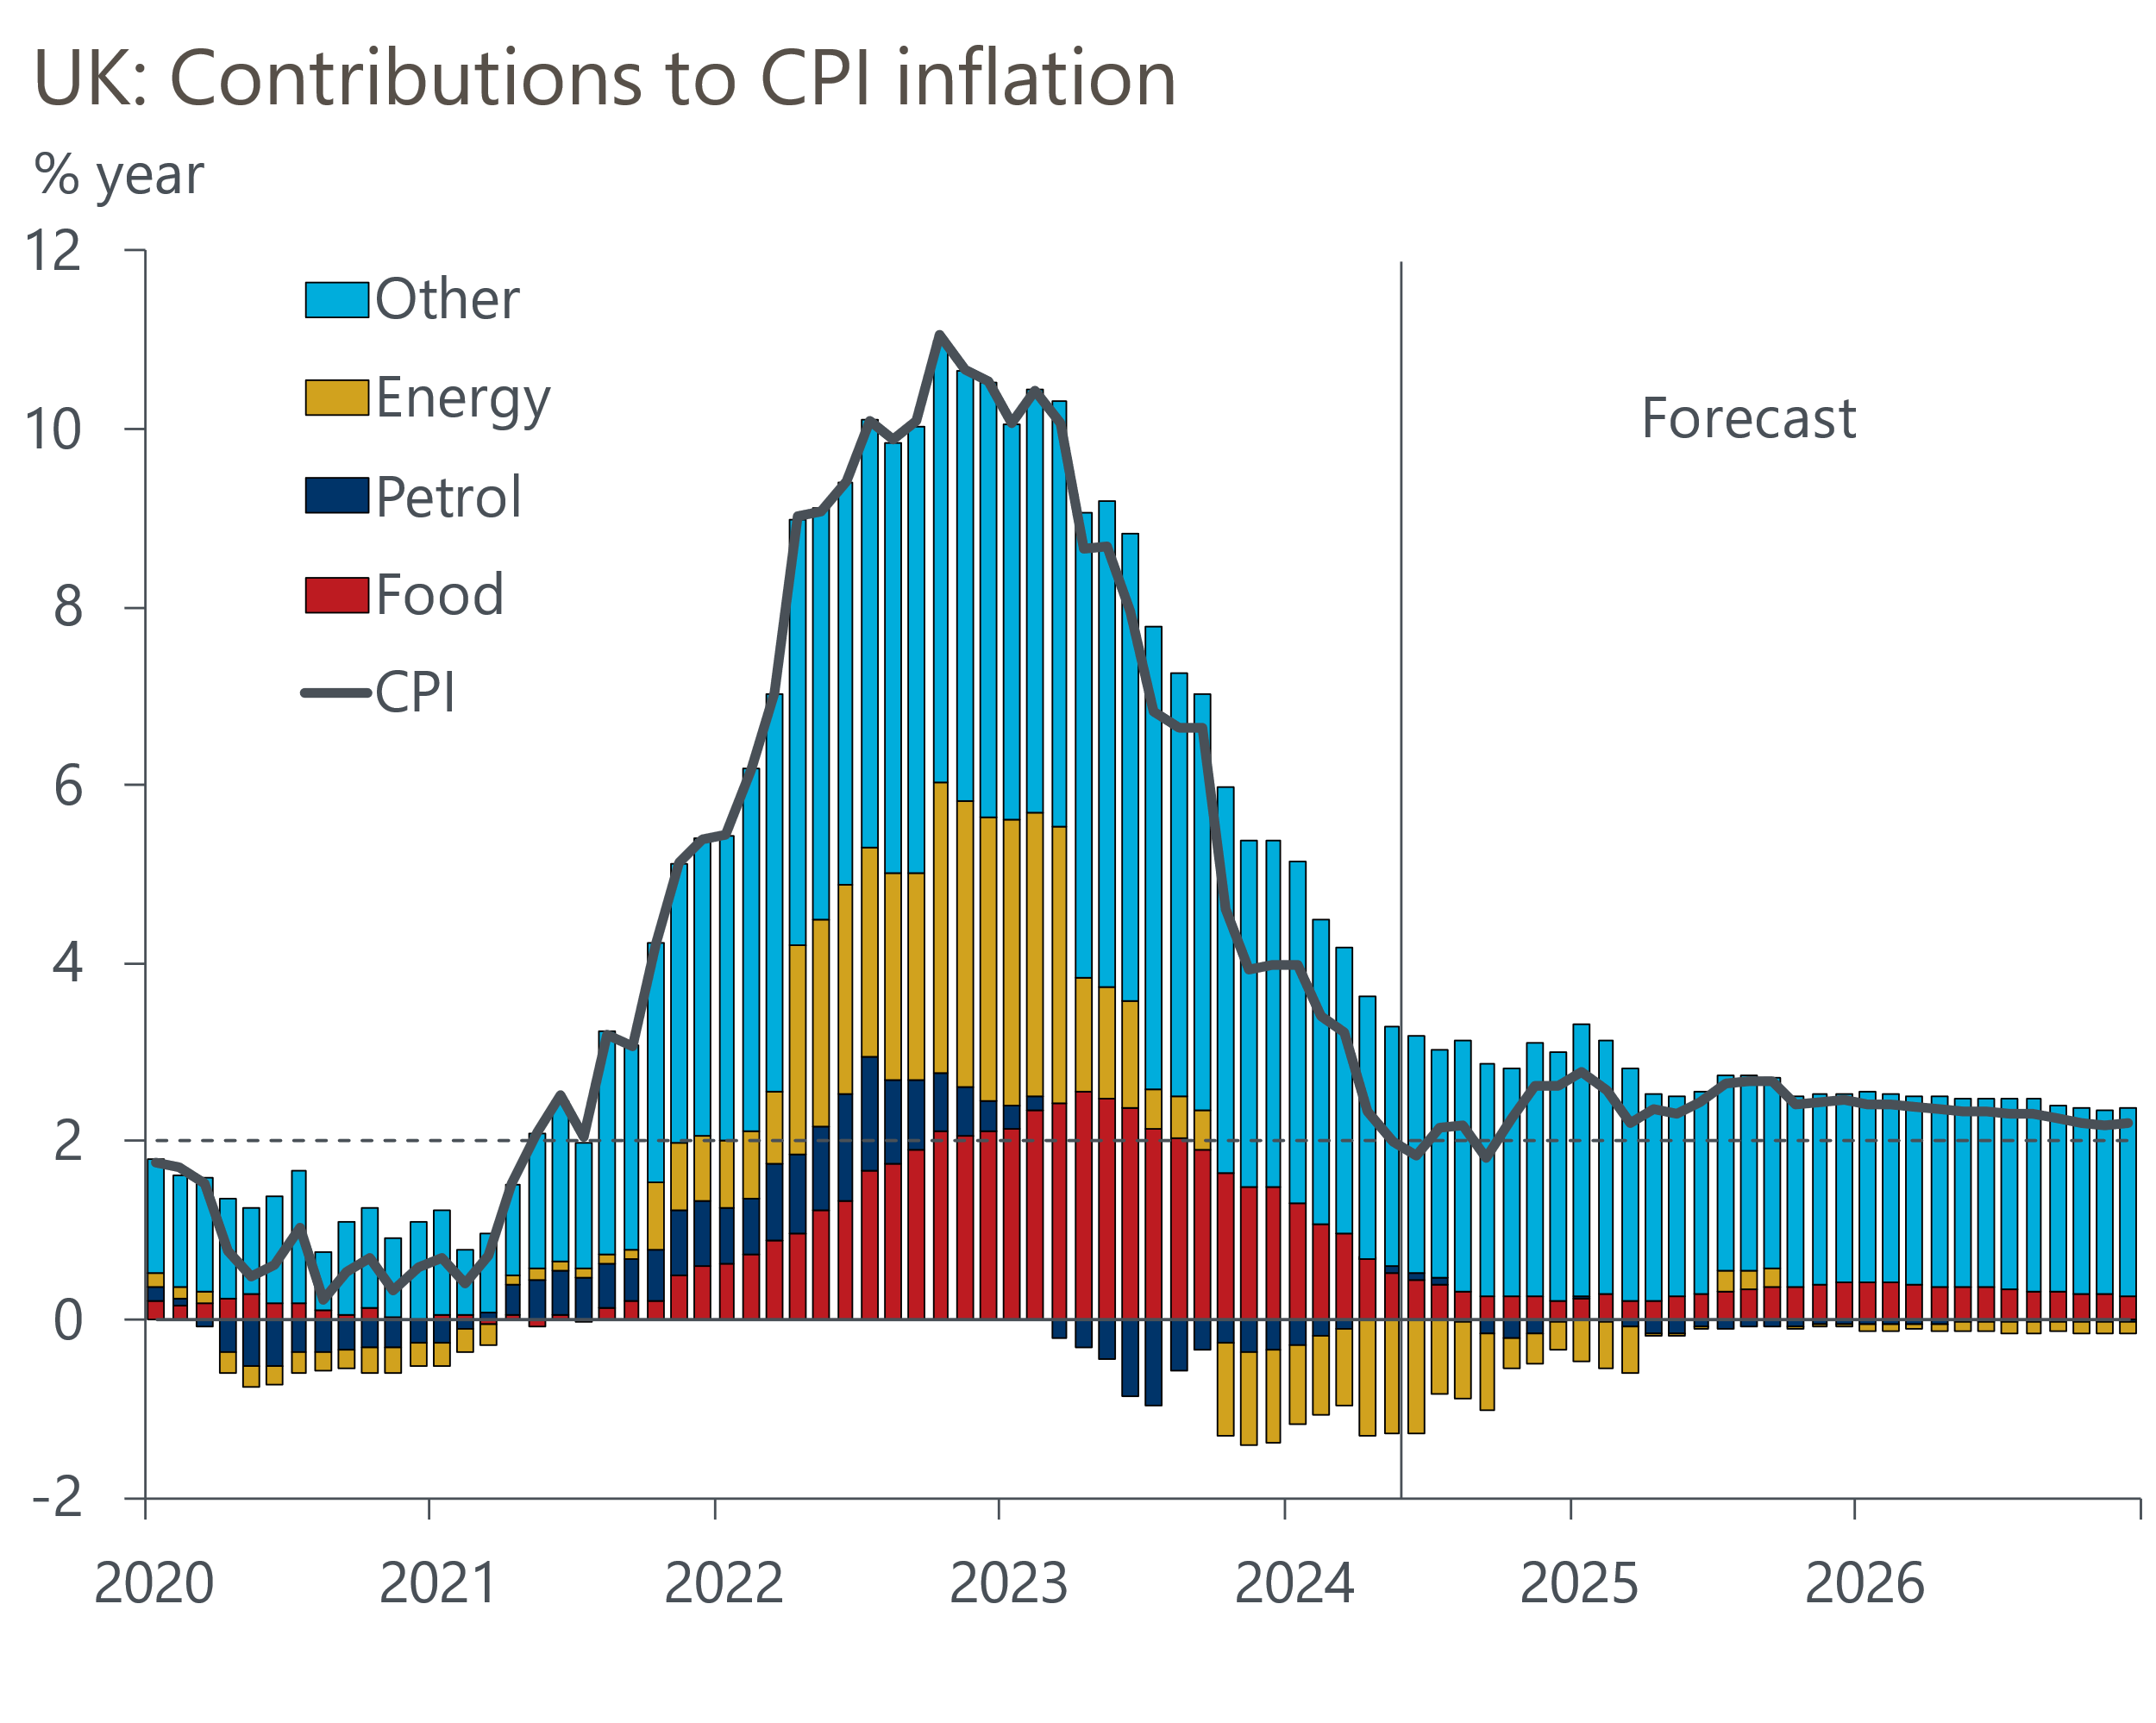
Source: Oxford Economics, Haver Analytics

